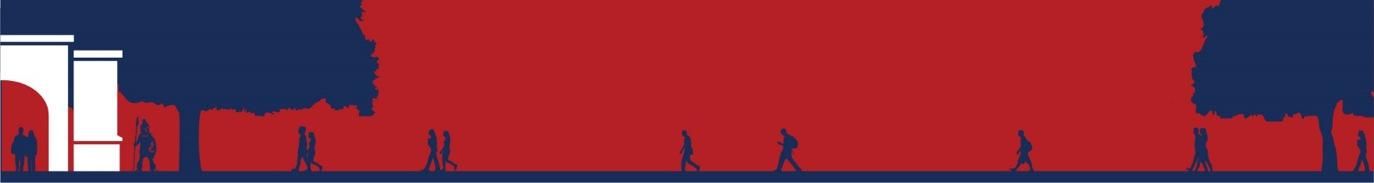

Psychology

**Course List**

1. **Psychology Course List**
2. **Gen Eds: 38-44 hours**
3. **Psychology Support Requirements: 6 hours**
4. PSY 113: General Psychology
5. MTH 127: Elementary Statistics
6. **Psychology Core Requirements:** **19 hours**
7. PSY 350: Human Diversity
8. PSY 323: Abnormal Psychology
9. PSY 333: Lifespan Developmental Psychology
10. PSY 343: Intro to Counseling
11. PSY 353: Physiological Psychology
12. PSY 403: Research Methods I
13. PSY 451: Senior Seminar (1)
14. **Concentration in Social Service Requirements: 19 hours**
15. SOC 233: Social Issues
16. SWK 413: Casework Methods
17. PSY 483: Internship (4)
18. SOC 123: Marriage & the Family
19. CRJ 356: Crisis Intervention
20. CRJ 323: Juvenile Delinquency
21. **Electives: As Needed**
22. **Total Hours Required for Graduation:** **124 hours**

